Kubernetes 02

- Create a Simple Pod Using YAML Task: Write a YAML file to create a Pod named firstpod with an nginx container. Verify the Pod creation using kubectl get pods and check the logs of the container using kubectl logs firstpod.
Create a Simple Pod Using YAML
Goal
Create a Pod named firstpod running a nginx container.
vi firstpod.yml
Step 1: Create YAML File
Create firstpod.yaml
apiVersion: v1
kind: Pod
metadata:
name: firstpod
spec:
containers:
- name: nginx-container
image: nginx
ports:
- containerPort: 80
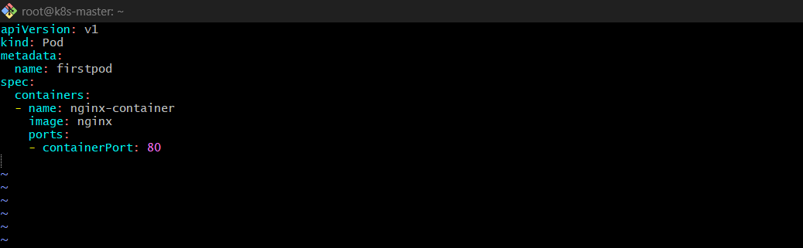

Explanation
- apiVersion: v1 → Core Kubernetes API
- kind: Pod → We are creating a Pod
- metadata.name → Pod name
- spec.containers → List of containers inside Pod
- image: nginx → Pulls nginx image from Docker Hub
- containerPort: 80 → Exposes port inside container

Step 2: Deploy Pod
kubectl apply -f firstpod.yml
Why apply?
- Creates resource if not exists
- Updates resource if exists
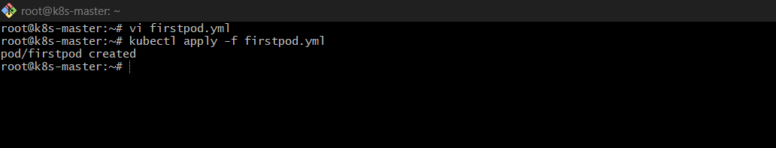

Step 3: Verify Pod
kubectl get pods
You should see:
firstpod Running
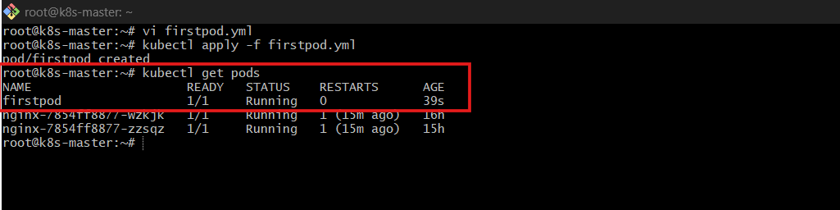
Step 4: Check Logs
kubectl logs firstpod
Shows container logs (nginx startup logs)
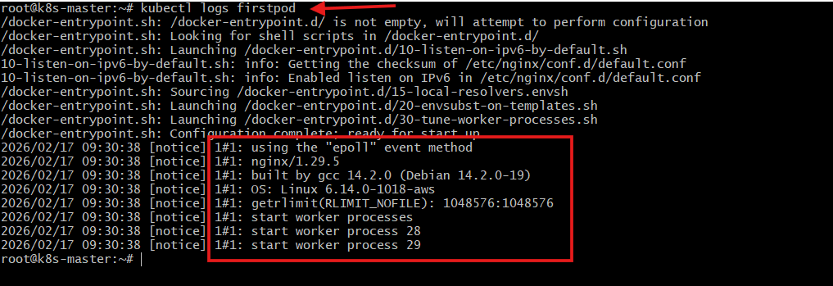

- Set Environment Variables in a Pod Task: Modify the YAML file to include environment variables myname: sabair and City: Hyderabad. Deploy the Pod and use kubectl exec <pod_name> -- env to check if the environment variables are set properly.
Set Environment Variables in a Pod
Goal
Add environment variables:
- myname = shahbaz
- City = Hyderabad
Step 1: Modify YAML
apiVersion: v1
kind: Pod
metadata:
name: firstpod-env
spec:
containers:
- name: nginx-container
image: nginx
env:
- name: myname
value: "shahbazz"
- name: City
value: "Hyderabad"
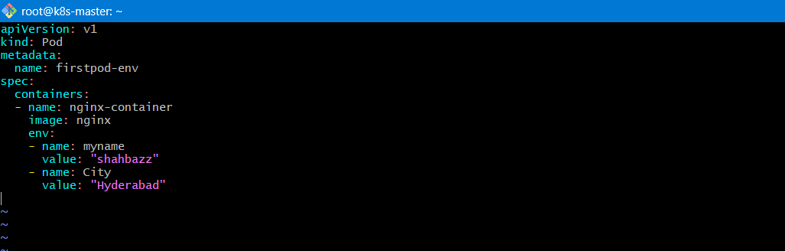
Explanation
- env: → Defines environment variables inside container
- name: → Variable name
- value: → Variable value

Step 2: Deploy
kubectl apply -f firstpod.yml
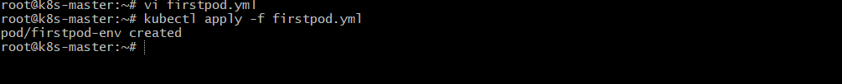
Check the pods:
kubectl get pods
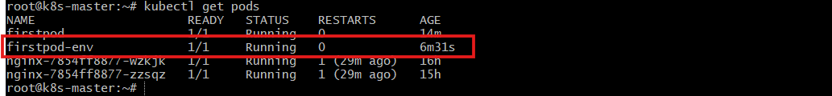
kubectl get pods -o wide
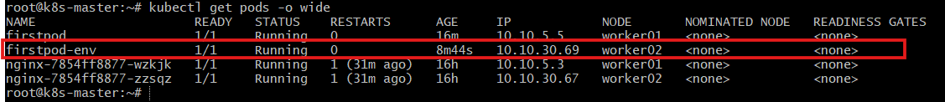
Step 3: Verify
kubectl exec firstpod-env – env
Why this works?
- exec runs command inside container
- env prints environment variables
You should see:
myname=shahbazz
City=Hyderabad
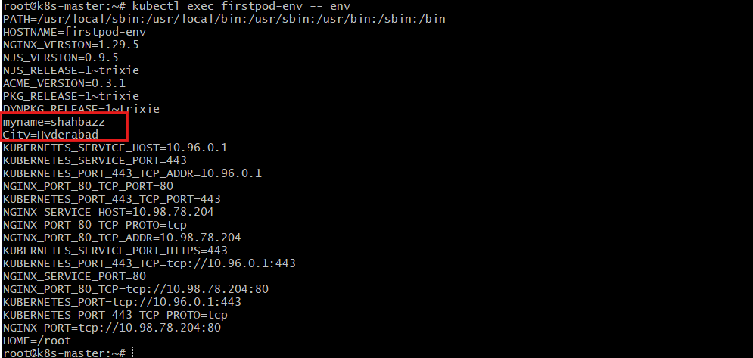

- Deploy a Pod with Commands (Args) in YAML Task: Modify the YAML file to add args that instruct the container to sleep for 50 seconds. Deploy the Pod and use kubectl describe pod to verify the args are correctly passed to the container.
Pod with Commands (Args)
Goal
Make container sleep for 50 seconds.
Step 1: YAML File
apiVersion: v1
kind: Pod
metadata:
name: sleep-pod
spec:
containers:
- name: busybox-container
image: busybox
args: ["sleep", "50"]

Explanation
busybox → Lightweight container for testing
args: → Pass arguments to container’s default command
Here it runs:
sleep 50
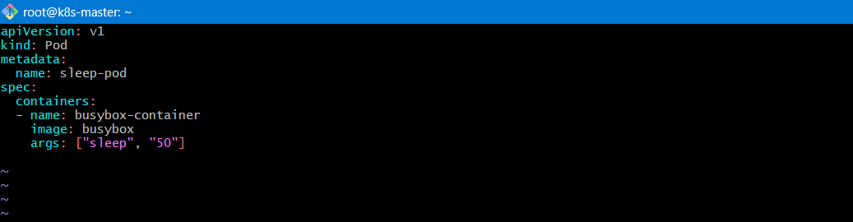
Step 2: Deploy
kubectl apply -f sleep-pod.yml
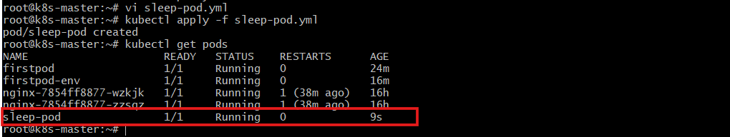
Step 3: Verify
kubectl describe pod sleep-pod
Check:
Args:
sleep
50
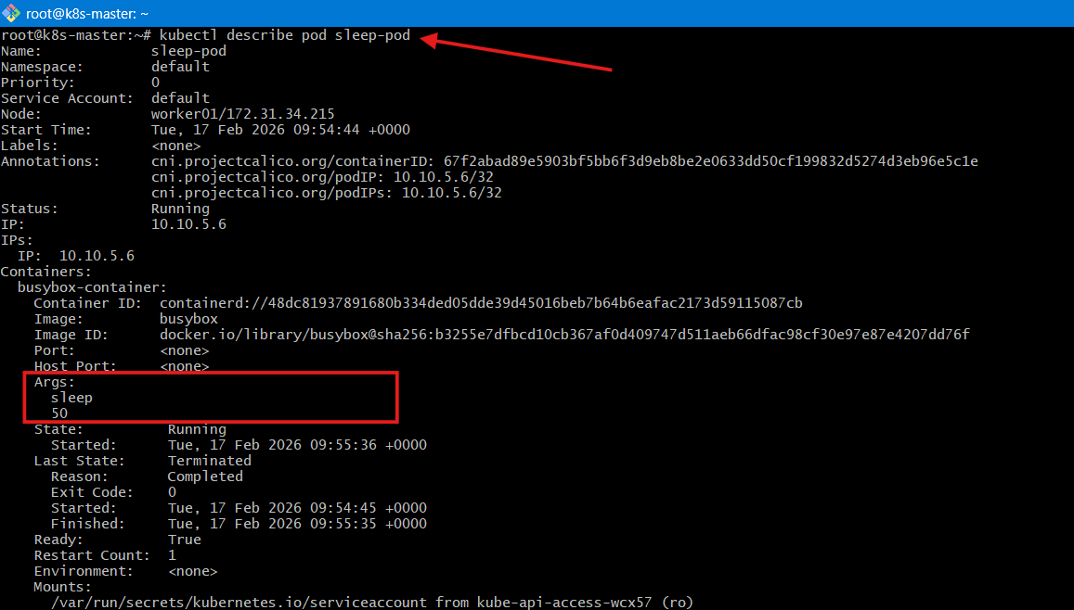

- Create a Pod with Two Containers Task: Create a YAML file to define a Pod with two nginx containers inside. Use kubectl exec to access both containers and verify that both containers can communicate through the same network (e.g., using telnet between them).
Pod with Two Containers
Goal
Create Pod with 2 nginx containers.
vi two-container.yml
Step 1: YAML
apiVersion: v1
kind: Pod
metadata:
name: two-nginx-pod
spec:
containers:
- name: nginx-1
image: nginx
ports:
- containerPort: 80

- name: nginx-2
image: nginx
command: ["/bin/sh"]
args:
- -c
- |
sed -i 's/listen 80;/listen 81;/' /etc/nginx/conf.d/default.conf && nginx -g 'daemon off;'
ports:
- containerPort: 81

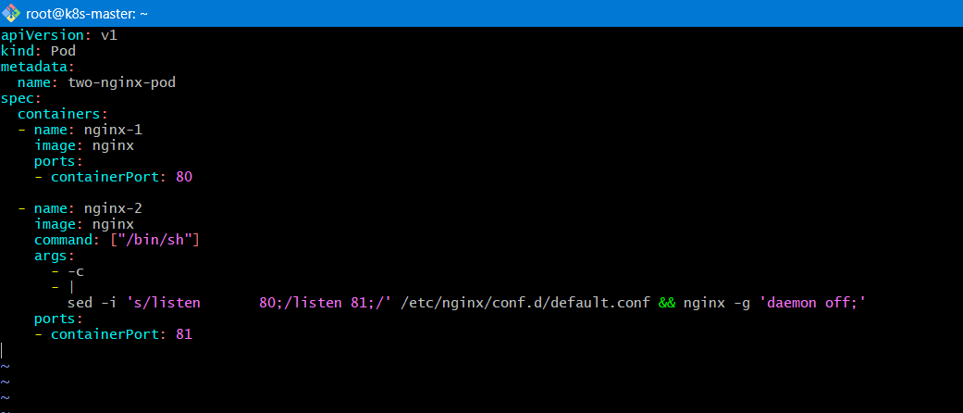
Explanation
- A Pod can contain multiple containers
- They:
- Share same network
- Share same localhost
- Share same storage (if volume defined)

Step 2: Deploy
kubectl apply -f two-container.yml
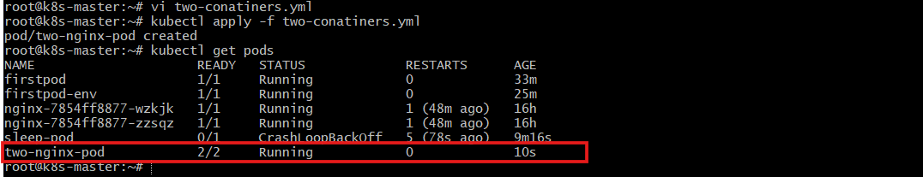
Step 3: Access Container 1
kubectl exec -it two-nginx-pod -c nginx-1 -- /bin/bash
-c specifies container name.
Test communication:
curl localhost:80
✔ Both containers share same IP inside Pod.
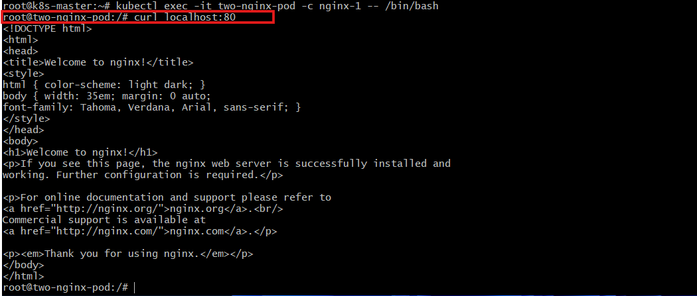

- Set Up an Init Container in a Pod Task: Modify the YAML to include an init container that sleeps for 30 seconds before the main containers start. Verify the init container's execution using kubectl describe pod and check the logs to confirm its completion.
Init Container
Goal
Run a container before main containers start.

Step 1: YAML
apiVersion: v1
kind: Pod
metadata:
name: init-pod
spec:
initContainers:
- name: init-container
image: busybox
command: ["sh", "-c", "sleep 30"]

containers:
- name: nginx-container
image: nginx
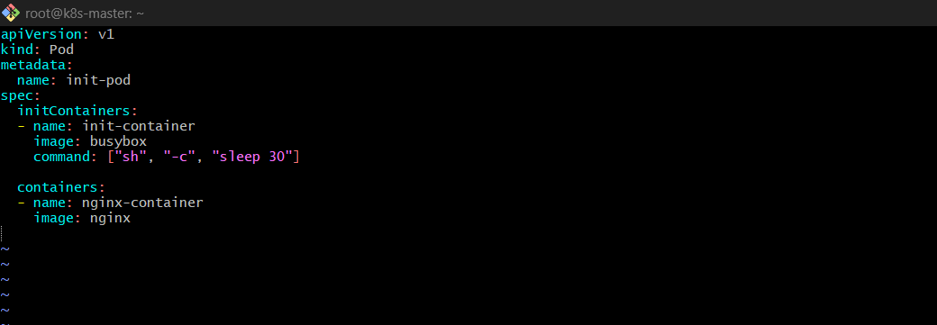
Explanation
- initContainers run first
- Must complete successfully
- Then main containers start

Step 2: Deploy
kubectl apply -f initpod.yml
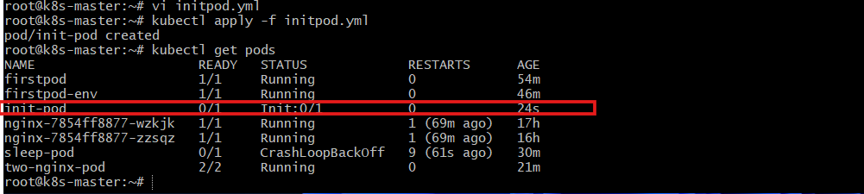
Step 3: Verify
kubectl describe pod init-pod
Check:
Init Containers:
State: Terminated
Reason: Completed
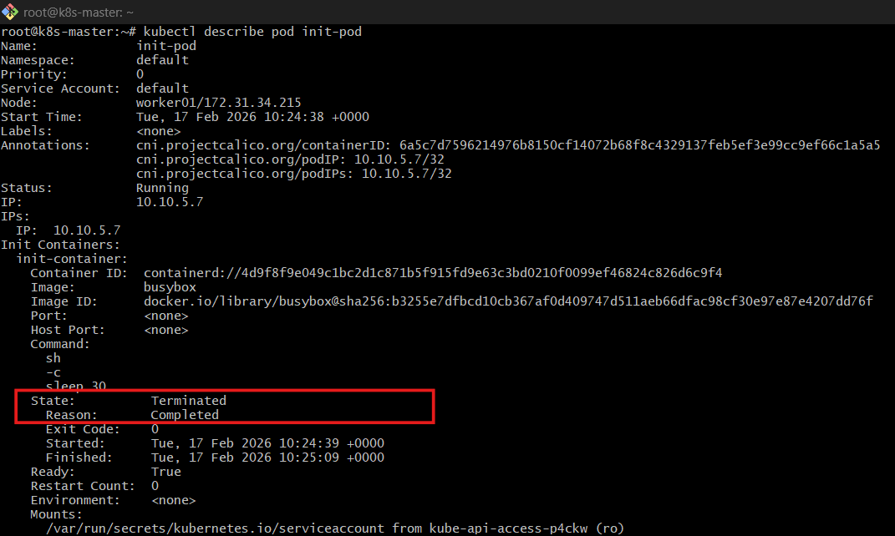

- Run a Dry Run Command to Generate YAML Task: Use the kubectl run nginx --image=nginx --dry-run=client -o yaml command to generate a Pod YAML definition. Modify the generated YAML to suit specific requirements (e.g., labels or environment variables) and deploy it.
Dry Run to Generate YAML
Step 1: Generate YAML
kubectl run nginx --image=nginx --dry-run=client -o yal > nginx.yml
Explanation
- --dry-run=client → Only generates YAML, does not create
- -o yaml → Output in YAML format
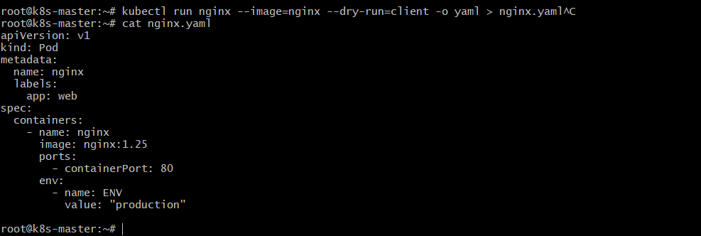
Step 2: Edit File
Add labels:
metadata:
labels:
app: web
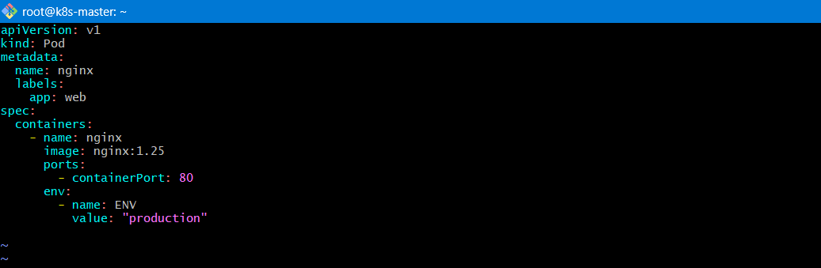
Step 3: Deploy
kubectl apply -f nginx.yaml
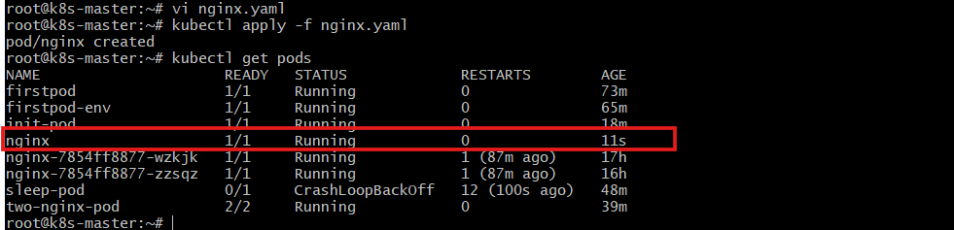

- Use kubectl apply vs kubectl create Task: Create a YAML file to define a Pod. First, deploy it using kubectl create -f <file_name>.yml and then modify the YAML (e.g., change the image version). Use kubectl apply to redeploy and verify the difference between both commands.
kubectl create vs apply
Using create
kubectl create -f firstpod.yml
- Fails if resource exists
- Used for one-time creation
Modify Image Version
Change:
image: nginx:1.25
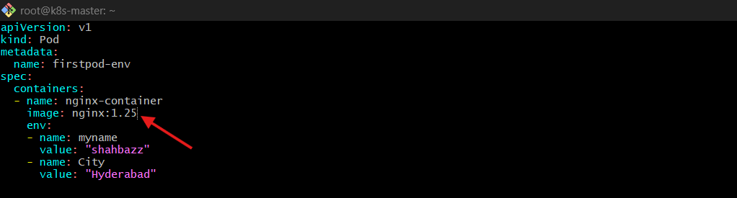
Use apply
kubectl apply -f firstpod.yml
- Updates existing resource
- Declarative method
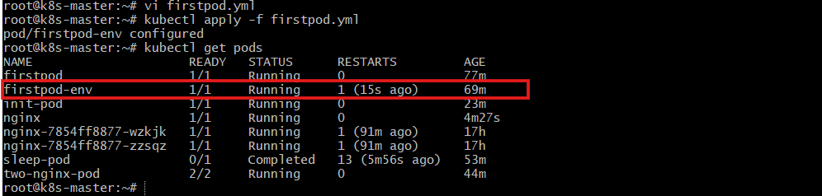

- Edit an Existing Pod Configuration Task: Use kubectl edit pod <pod_name> to modify the running Pod's environment variables or image. After making the changes, verify if they took effect by checking the container logs or environment variables using kubectl exec.
Edit Running Pod
kubectl edit pod firstpod
What Happens?
- Opens YAML in editor
- Some fields editable
- Some require Pod recreation
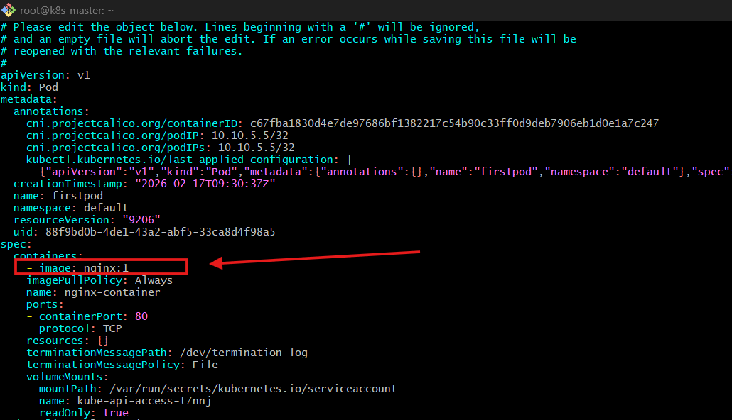
Verify:
kubectl describe pod firstpod
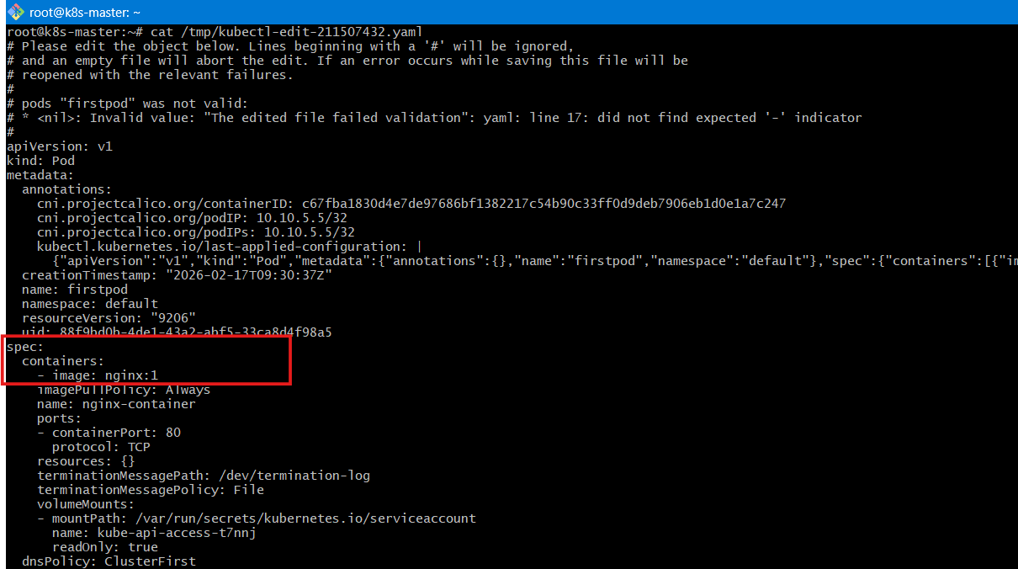

- Expose a Pod Using a Service Task: Create a YAML file to expose your firstpod using a Service (ClusterIP). Ensure that your service is exposing the Pod on port 80 and verify it using kubectl get svc.
Expose Pod with Service
Why?
Pods are temporary. Service provides stable access.

Step 1: Add Label to Pod
metadata:
labels:
app: web
Step 2: Create Service YAML
apiVersion: v1
kind: Service
metadata:
name: firstpod-service
spec:
type: ClusterIP
selector:
app: web
ports:
- port: 80
targetPort: 80
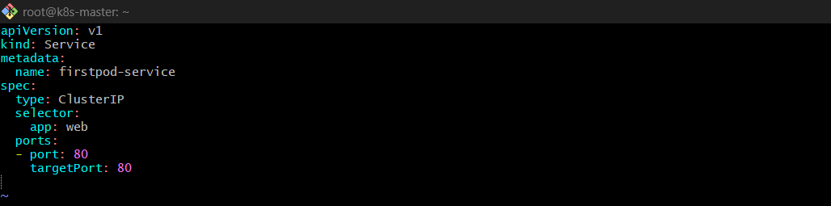
Step 3: Deploy
kubectl apply -f service.yml
Step 4: Verify
kubectl get svc
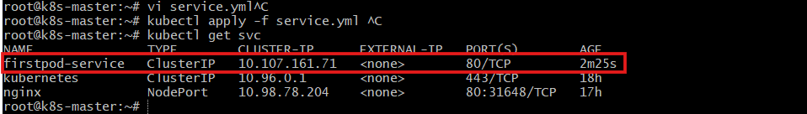

- Pod with Resource Limits and Requests Task: Add resource requests and limits to the containers in your YAML file. Specify CPU and memory requests/limits for both containers and deploy the Pod. Use kubectl describe pod to verify if the resource configurations are correctly applied.
Pod with Resource Limits
Why?
Prevents containers from using too much CPU/Memory.

YAML
apiVersion: v1
kind: Pod
metadata:
name: resource-pod
spec:
containers:
- name: nginx-1
image: nginx
resources:
requests:
memory: "64Mi"
cpu: "250m"
limits:
memory: "128Mi"
cpu: "500m"
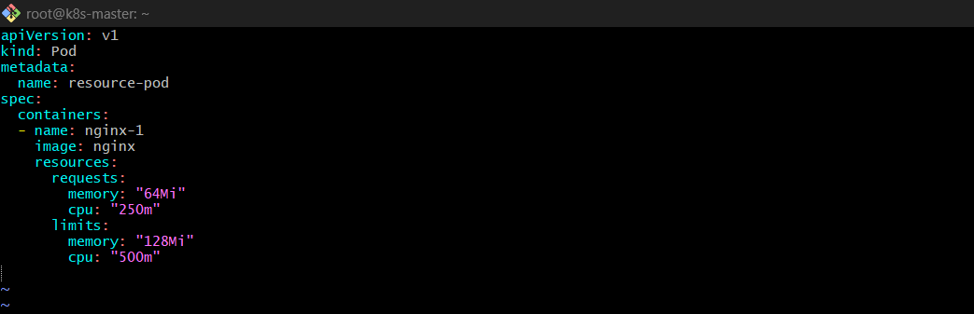
Explanation
requests → Minimum guaranteed resources
limits → Maximum allowed resources
250m → 0.25 CPU core
Mi → Mebibyte (memory unit)

Deploy
kubectl apply -f resource-pod.yml
Verify
kubectl describe pod resource-pod
Check under:
Limits:
Requests:
